Bryan Chambers, Sofía Díaz, Alberto Castillo

Technical University of Munich

# Author Note

Max Planck-Institute for Plasma Physics & Technical University of Munich

Advanced Lab Course (FOPRA) offered at winter 18-19 semester at TUM

[mrbryanchambers@gmail.com](mailto:mrbryanchambers@gmail.com), [alberto.castillo@tum.de](mailto:albertocastillo@tum.de), [sofia.diaz@tum.de](mailto:sofiadiaz@tum.de)

# 

# Introduction

Plasma research is an extensive and multi-nationally collaborative endeavor. It has a wide range of industrial applications with much to still be discovered and hopefully someday high yield fusion will result from the decades of investigation in it. In this experiment, a plasma is created in a low pressure vacuum by a thermionic discharge of electrons emitted from a tungsten filament in a gas mixture of helium and argon. Some of the questions that will be addressed are behaviors of the plasma such as how the initial neutral gas is ionized or how the harmonic wavelength of standing waves generated depend on input parameters such as the pressure of the gas, the current through the filament, and the driving frequency that creates the standing waves. These factors are important to know for general research into plasma.

# 

# II. Theory

Plasma is frequently referred to as the fourth state of matter. What constitutes a plasma is a bit broad but something that behaves as a neutral gas or fluid of ion and electrons that is a product of ionization processes can be considered a plasma. Consider a plasma that consists of ions and electrons. The ion density can be denoted as $n_{i}$ and the electron density as $n_{e}.$ If an external alternating voltage is applied to the plasma the ion and electron fluid will each have unique oscillations, considering the fact that they have opposite charges and mass one would not expect these oscillations to be in phase. The plasma frequency is given as the frequency for which the electrons oscillate with respect to the ions

$ω_{pe}=\sqrt{\frac{e^{2}n_{e}}{ϵ_{o}{m_{e}}_{}}}$ (1)

The plasma chamber consists of two chambers separated by a conducting grid. The plasma is created by thermionic emission of electrons in a filament that ionizes the He-Ar gas mixture in a low pressure (of order ${10}^{-2}Pa)$ environment. The electron current deposited into the plasma is given by *Richardson’s law.*

$j(T) =A_{R}T_{f}^{2}$ exp( $-\frac{W_{e}}{k_{B}T_{f}})$ (2)

Where $A_{R}$ is the Richardson constant ($6.0⋅10^{5} A/(m^{2}K^{2})$, $W_{e}$ the work function (4.54 eV for tungsten) tun, and $T_{f}$ the temperature of the filament. For tungsten. So once the electrons are emitted from the filament they are accelerated by the grid in the chamber, see fig. 2.

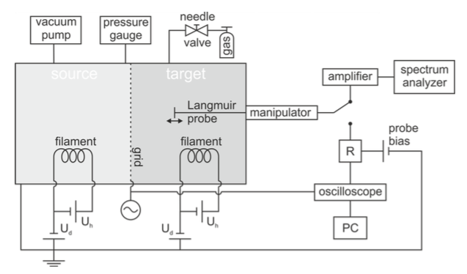

Fig. 2: Block diagram depicting the pertinent experimental instruments. Emission currents in from the filaments are controlled by variable capacitors connected in parallel. A Grid applies an external field to accelerate the ions. Langmuir probe measures the amplitude of generated plasma waves in mV.

Ionized electrons have a reasonably large path in the plasma, of order 1 m. This can be attributed to the fact that they are in a low pressure environment. In order to increase the collision rate and resulting plasma production rate created by ionization, the electrons are confined by a magnetic cusp configuration (see Section III).

Referring to fig. 2, there is a Langmuir probe that has the function of measuring the current and voltage of the plasma. It consists of a tungsten wire that has a bias voltage applied to it, *U.* The theoretical expression for the current it measures is

$I=I_{e,sat}exp\left(\frac{e({ϕ_{p}-U)}_{}}{k_{B}T_{e}}\right)+I_{i,sat}$ (3)

Where $T_{e}$ is the temperature of the electron plasma and $I_{e, sat}, I_{i, sat}$ are the saturation currents for the electron and ion plasmas respectively, and $I_{i,sat}$. The plasma is effectively saturated when it can no longer produce more current. A characteristic curve of the current is shown below in fig. 3 which labels the expected regions of the saturation currents.

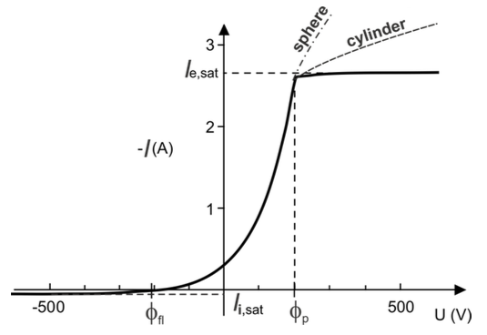

Fig. 3: Shows a characteristic curve of the current for a Langmuir probe in a plasma.

For high values of negative bias, the Langmuir probe will only measure an ion current. Another relevant quantity that can be deduced from the characteristic curve is the floating potential, $ϕ_{p}$ for the electrons and $ϕ_{fl}$ for ions. It is simply the value of the potential that coincides with the saturation current. From this condition, the Maxwell velocity distribution provides the saturation current

$I_{i, sat}=0.61enS\sqrt{\frac{{k_{B}T_{e}}_{}}{m_{i}}}$ (4)

Where S is the surface area of the probe.

Likewise for positive bias voltage only electrons will reach the probe. The electron saturation current is given as

$I_{i, sat}=-enS\sqrt{\frac{{k_{B}T_{e}}_{}}{2πm_{e}}}$ (5)

A quantity of particular importance in the field of plasma physics is the plasma density. The most reliable way to determine it is the *plasma oscillation method*. In this method a relatively thin electron beam is injected into the plasma and creates an instability of oscillations at the electron plasma frequency $f_{pe}=ω_{pe}/2π.$ Ion Acoustic waves.

$${c_{}}_{s }=\frac{ω}{k} =\sqrt{\frac{k_{B }T_{e}}{m_{i}}}$$

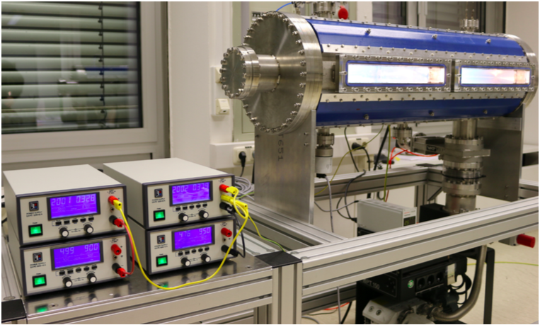

Fig. 1: A photograph showing the plasma chamber (right) and the controls for the filament current and external voltage of each the two chambers (left).

## 

## 

## III. Experimental setup

The double plasma experiment consists of a vacuum chamber of 900 mm long and 315 mm of diameter. The chamber is divided into 2 halves by a stainless steel mesh. The plasma is contained by a magnetic field generated by 4 magnets in cusp arrangement, which creates a higher density region in the center of the container where the magnetic field is weaker.

The plasma is generated in the right half of the chamber (source chamber) by thermionic emission of a Tungsten filament by a heating current ($I_{h })$. This current should be in the range of 4-7 A and never higher than 10 A. This filament is biased at a different voltage $U_{d }$ (higher than 30 V and lower than 200 V) than the one of the walls which are grounded. This voltage accelerates the electrons towards the wall causing the ionization of the neutral particles of the gas. The chamber is filled with a mixture of He and Ar at pressures of the order of 10 mPa. This pressure is maintained by a molecular vacuum pump and can be modified by operating a valve that introduces the gas mixture into the chamber. This pressure $P_{0 }$ is measured with a gauge connected to the cylinder and can never surpass 0.1 Pa.

The left half of the chamber, called the target chamber, includes a tungsten filament, similar to the one in the source chamber. A thin electron beam can be produced from this filament in order to generate instabilities inside the plasma that amplify the waves for a frequency equal to the plasma frequency. This chamber also contains a Langmuir probe which in this case consist of insulated thin tungsten rod that can be moved along the axis of the cylinder in order to measure at different points.

# IV. Method and Analysis

**IV.I Plasma generation and control parameters**

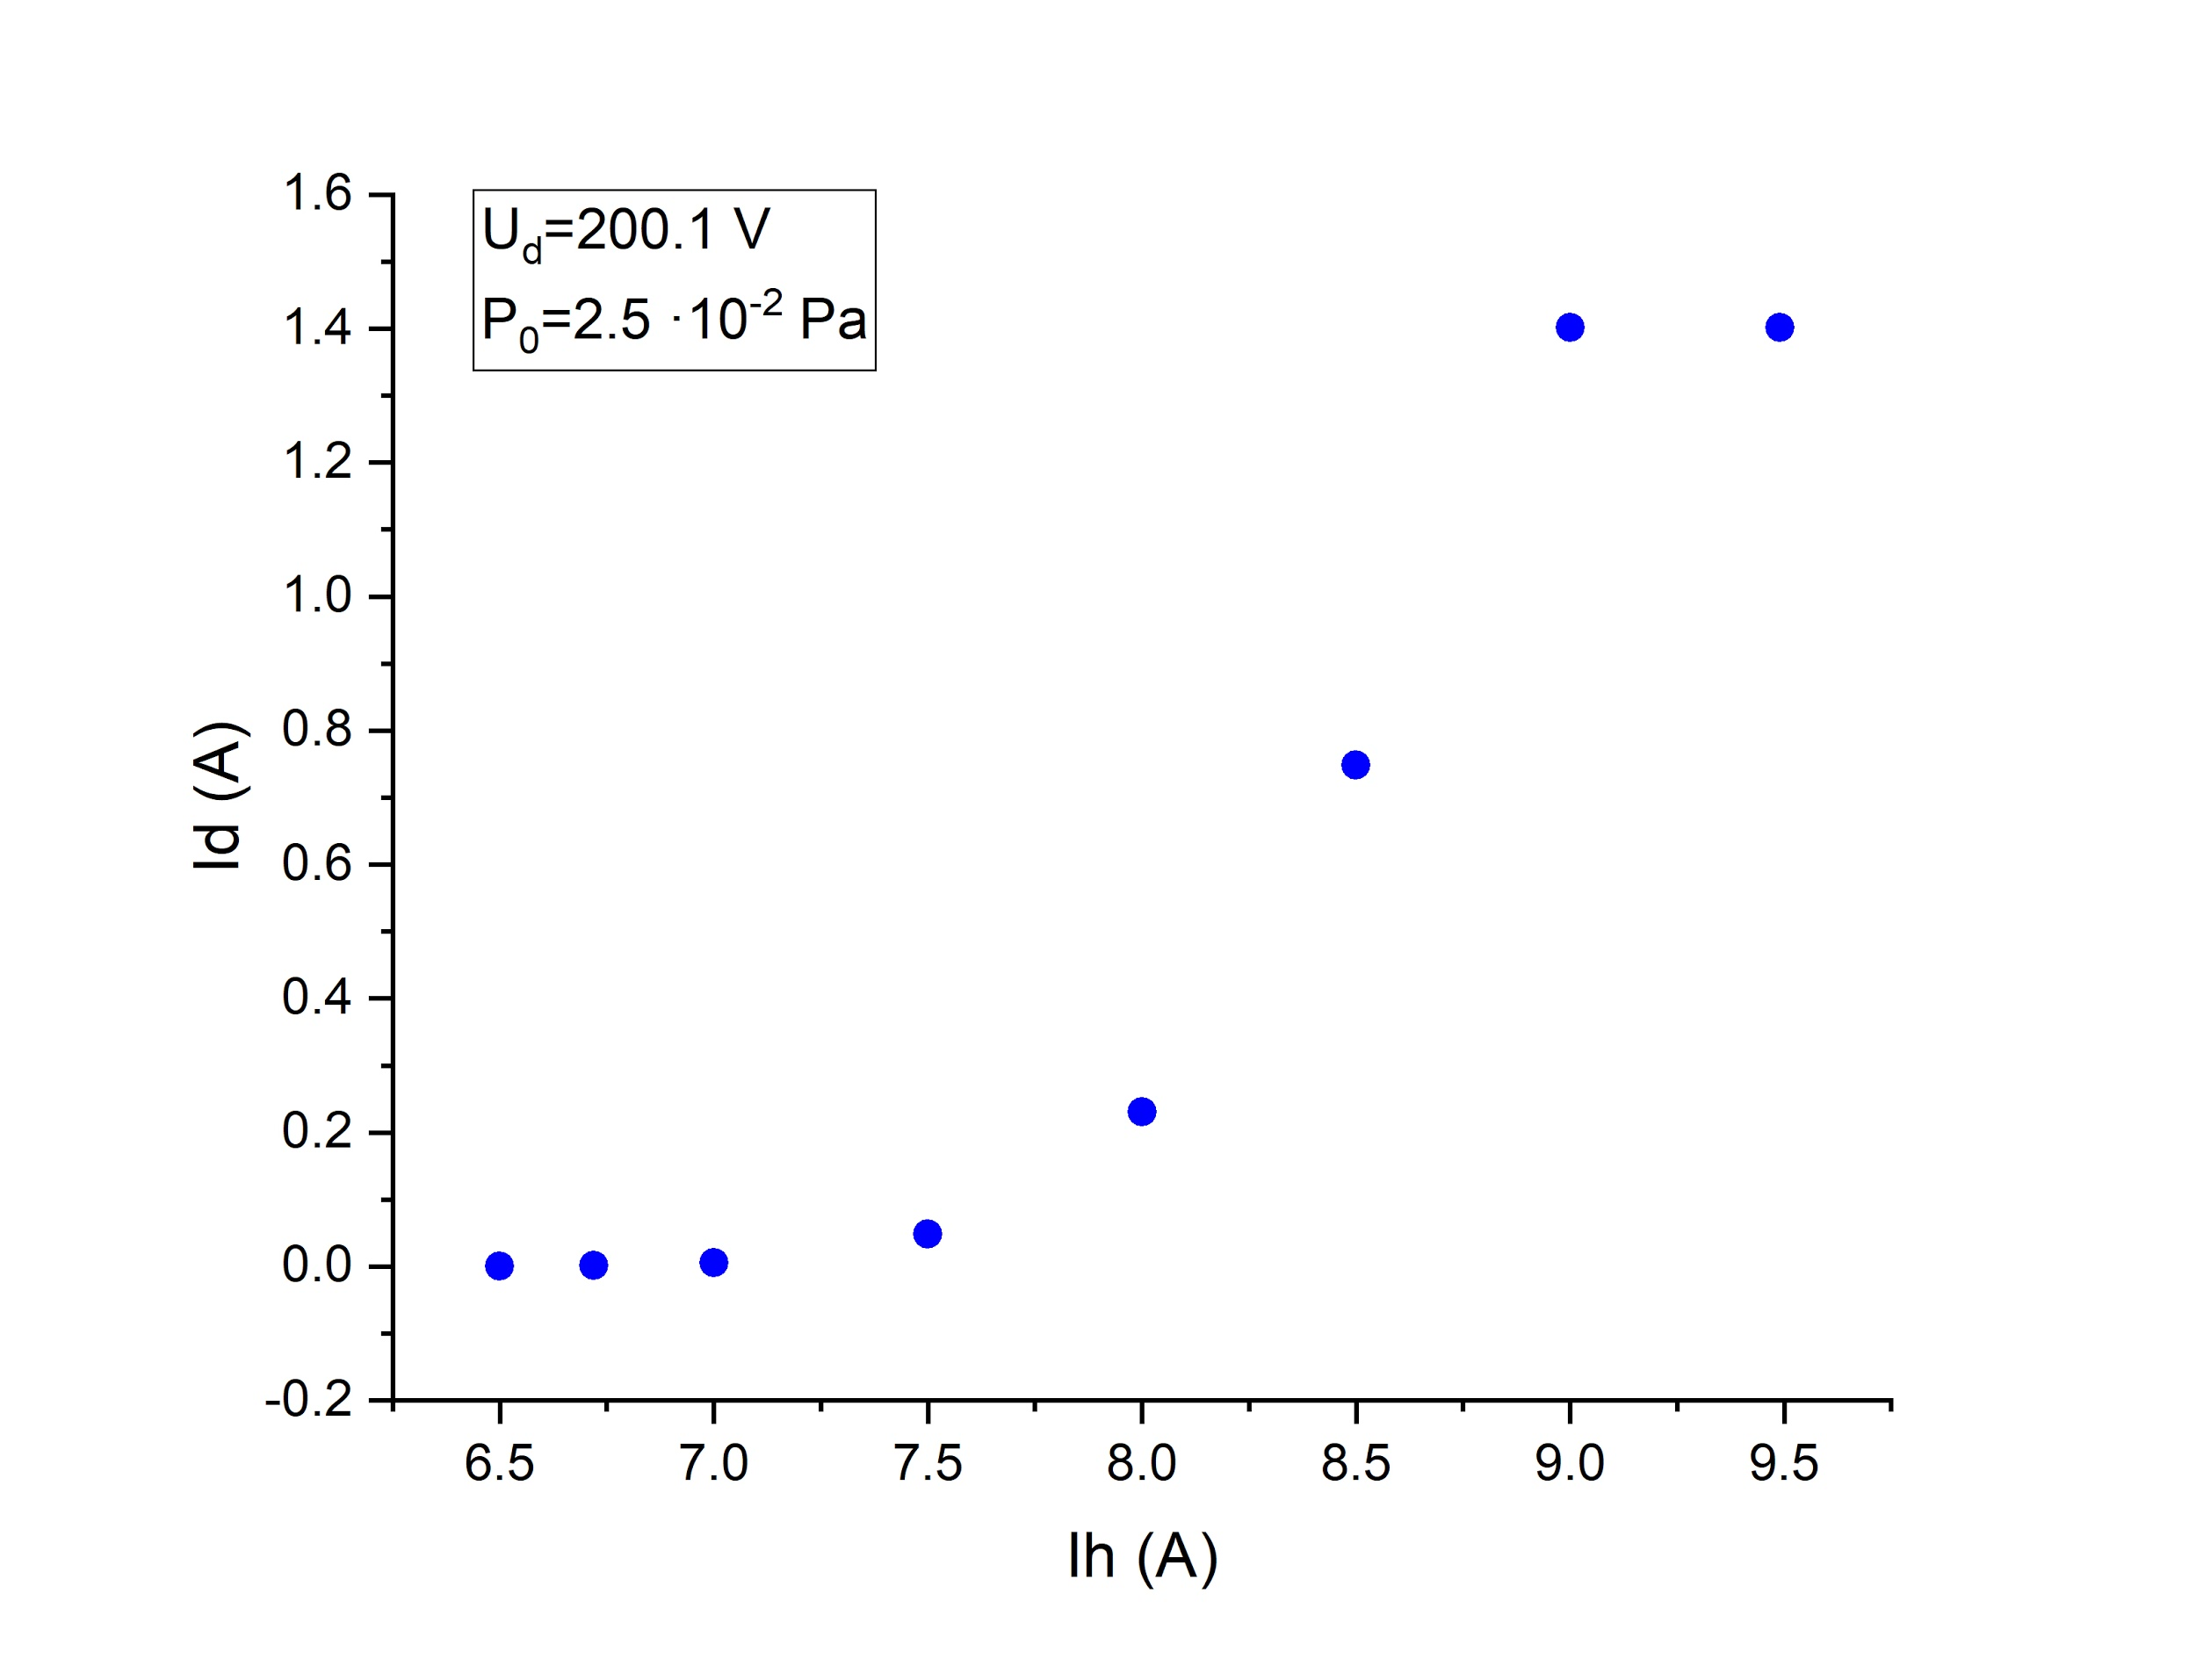In this first part of the experiment, the discharge current $I_{d}$ is measured as a function of the control parameters that we introduced in the setup section. The discharge current can be understood as a measurement of the ionization of the plasma. It is the current that flows from the plasma to the walls of the container, thus the current increases with the number of charge carriers. Three different measurements will be performed. In each of them the variation of the discharge current will be observed as one of the control parameters varies and the other two remain constant. For this purpose, first, we established the ranges allowed by the limitations of the control parameters in which the discharge current is observed.

In the previous graph, it is observed that there is a non-linear dependence of the discharge current with respect to the heating current. This is consistent with Richardson’s Law for thermionic emission. The temperature of the filament increases with the heating current which results in an increase of the electron current emitted from the filament. This causes more collisions of electrons with the neutral background and therefore in a higher ionization in the gas which leads to an increased discharge current. It is seen that for heating currents below 6.7 A, no discharge current is observed by the measuring equipment, which means that below this current there are not enough emitted electrons to induce an observable ionization. It is also apparent on the graph that beyond the threshold of 9.0 A, the discharge current stabilizes on the value of 1,402 A and does not increase any further. A likely explanation for this is that the voltage supply equipment cannot maintain the bias potential between the wall and the filament for high discharge currents.

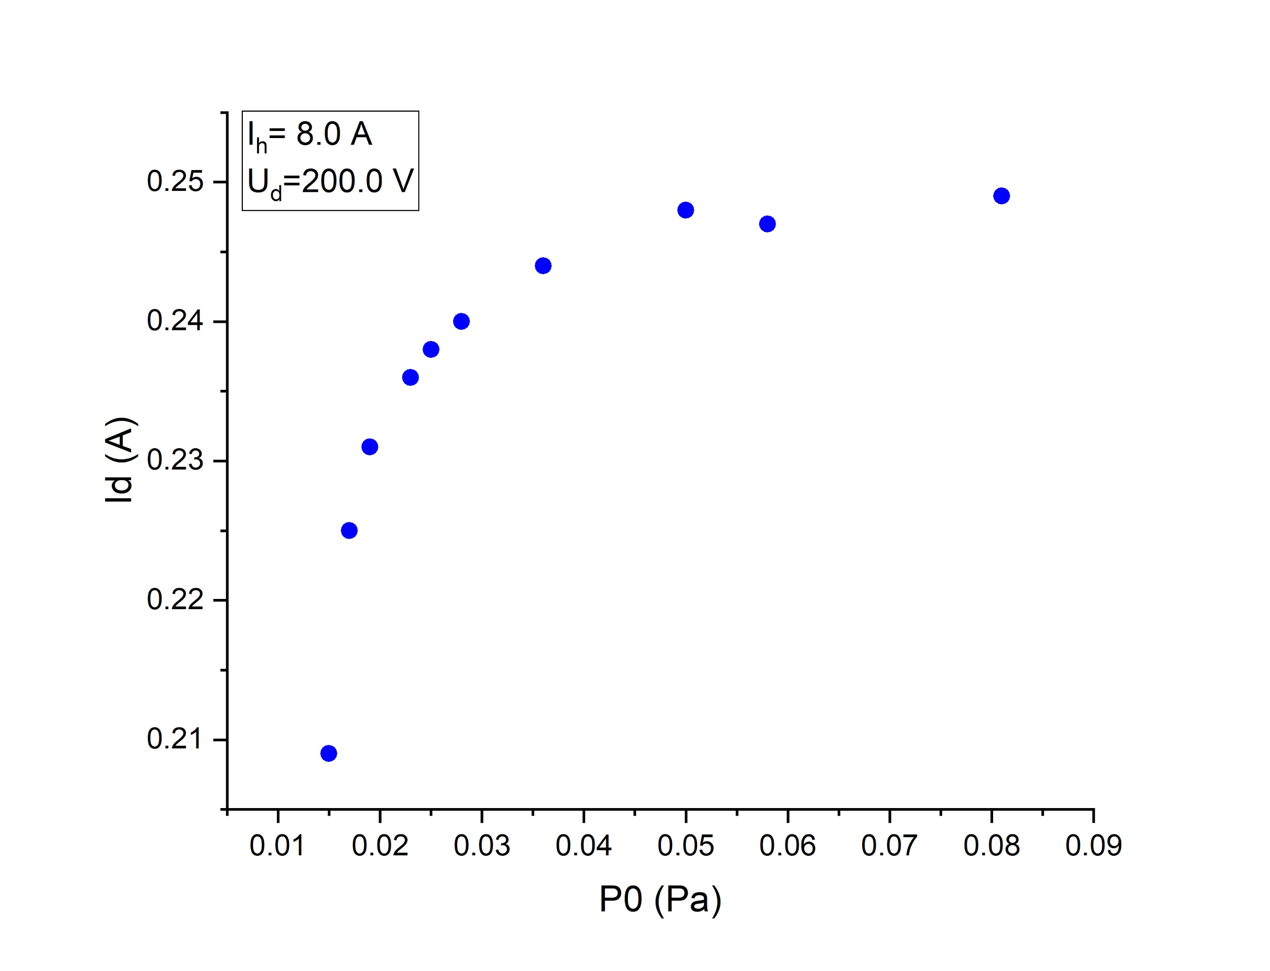

In this second graph, we can observe how the discharge current, and thus the ionization of the plasma, increases as the neutral pressure arises. For a fixed heating current and bias voltage, there is a fixed number of thermionic electrons emitted. As the concentration of neutral particles increases, the chances of electron-neutral ionization collisions, while electrons are travelling towards the wall, are higher. As we have a fixed number of emitted electrons, there is a maximum number of ionization collisions, given by the case in which all emitted electrons collide with a neutral particle before arriving to the walls. This is consistent with the recorded graph as we see at first an increase in the discharge current with $P_{0 }$ and, after $5.0 ·10^{-2 }$ Pa, the current tends to asymptotically stabilize around the value of 0.248 A. Due to the limitations of this experiment, the pressure can not surpass 0.1 Pa. Therefore, we cannot test if this trend continues for further values.

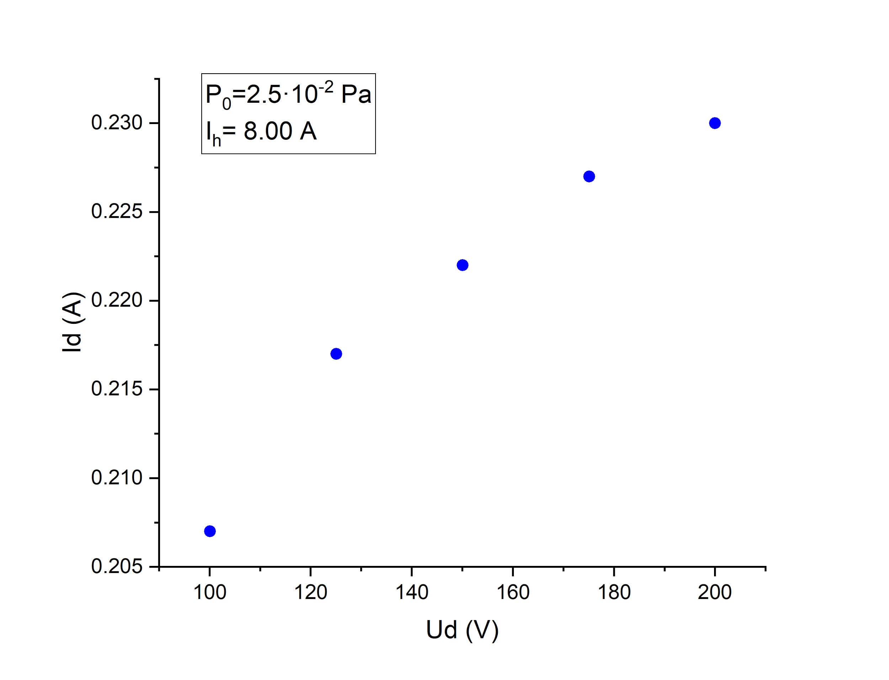

In the last graph, there is a fixed number of thermionic electrons emitted and also a fixed the number density of neutral particles. We observe an increase in the discharge current as the bias potential increases. As the number density of neutral particles and emitted electrons remain constant, the only factor that can influence the change in the discharge current is the cross section of ionization by electron impact. This increase in $I_{d }(U_{d })$ can only be explained as a dependency of the ionization cross section with the kinetic energy of the electrons, which is higher with higher potentials. In Fig ( ) we can observe the dependency of the cross-section of helium and argon as a function of the kinetic energy of the incident electrons. For values of the ratio lower than around 100 eV, this cross-section increases with the ratio and it decreases for higher values.

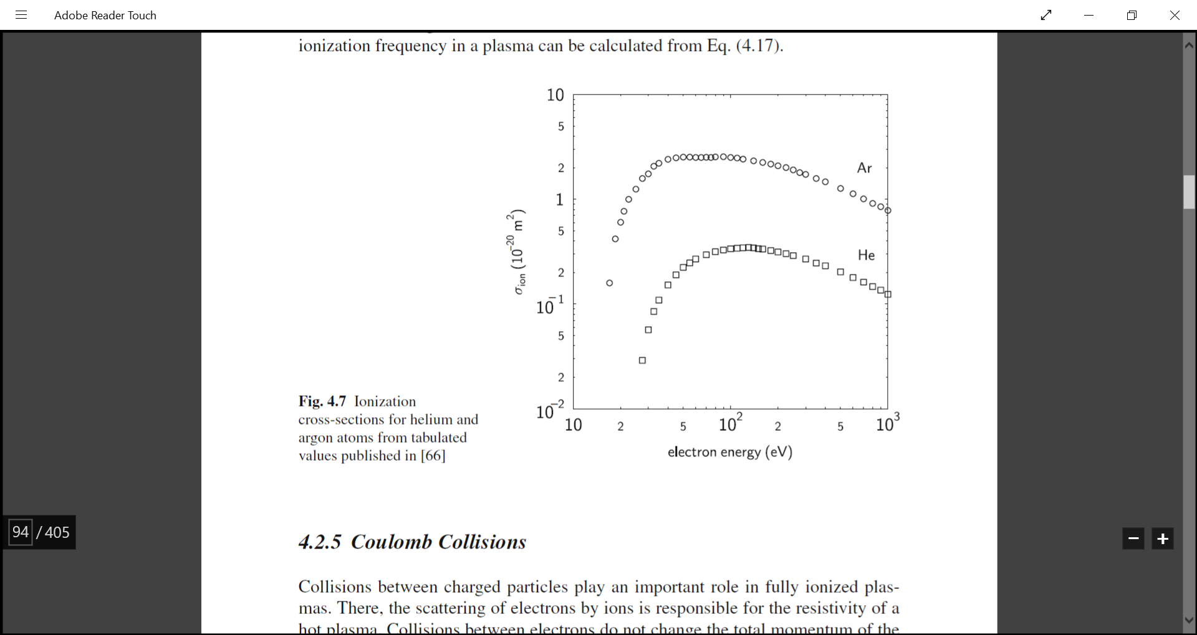

The fact that the ionization of the plasma increases with the bias potential implies that the measurements are taken in the range of energies lower than 100 eV. The kinetic energy for electrons accelerated in a electric potential in eV is equivalent to the number of V of the potential difference. For He, the

ionization energy is 24.59 eV and for Ar, 15.76 eV. The energies of the electrons accelerated by the bias potential are in the range of 100 to 200 eV, which is mostly beyond the threshold where cross-section starts to decrease, so our results suggest that the collisions must happen at lower energies than the maximum energy at which the electrons could be accelerated by the bias potential. One possible explanation for this could be energy loss due to elastic scattering with background electrons.

## IV.II Plasma density from the plasma oscillation method.

In this second part of the experiment, an electron beam will be introduced in the target chamber through a second tungsten filament. A Langmuir probe will be introduced also in this chamber in order to measure the frequencies at which the plasma oscillates. When the electron beam produced in the filament is thin enough ($n_{beam}<< n$) and the kinetic energy from the beam is 20 times lower than the electron temperature ($k_{B }T_{e })$, instabilities are created for oscillations at frequencies equal to the plasma frequency. The Langmuir probe will be set close to the filament where the instabilities are being generated and connected to a frequency analyzer in order to use it as an antenna. In this spectral analyzer, the amplitude of the oscillations is seen as a function of frequency. In order to detect the peak that corresponds to the plasma frequency the heating current $I_{h }$ is varied. The amplitude peaks are seen more clearly at high values for the $I_{h }$. Apart from the peak corresponding to the plasma frequency, others peaks could appear. In order to distinguish which one of these peaks correspond to the $ω_{pe }$, the $I_{h }$ is lowered. The correct peak must also decrease in amplitude as the current is lowered and becomes thinner and its frequency can be measured in this way. Then, the number density of the charge carriers of the plasma n is calculated from the plasma frequency for each value by using eq. (1).

For this part of the experiment, we measure the plasma frequency as a function of the three control parameters.

First, we vary the neutral pressure keeping the heating current of the source chamber at a constant value of 8.13 A and the bias potential at 200.1 V.

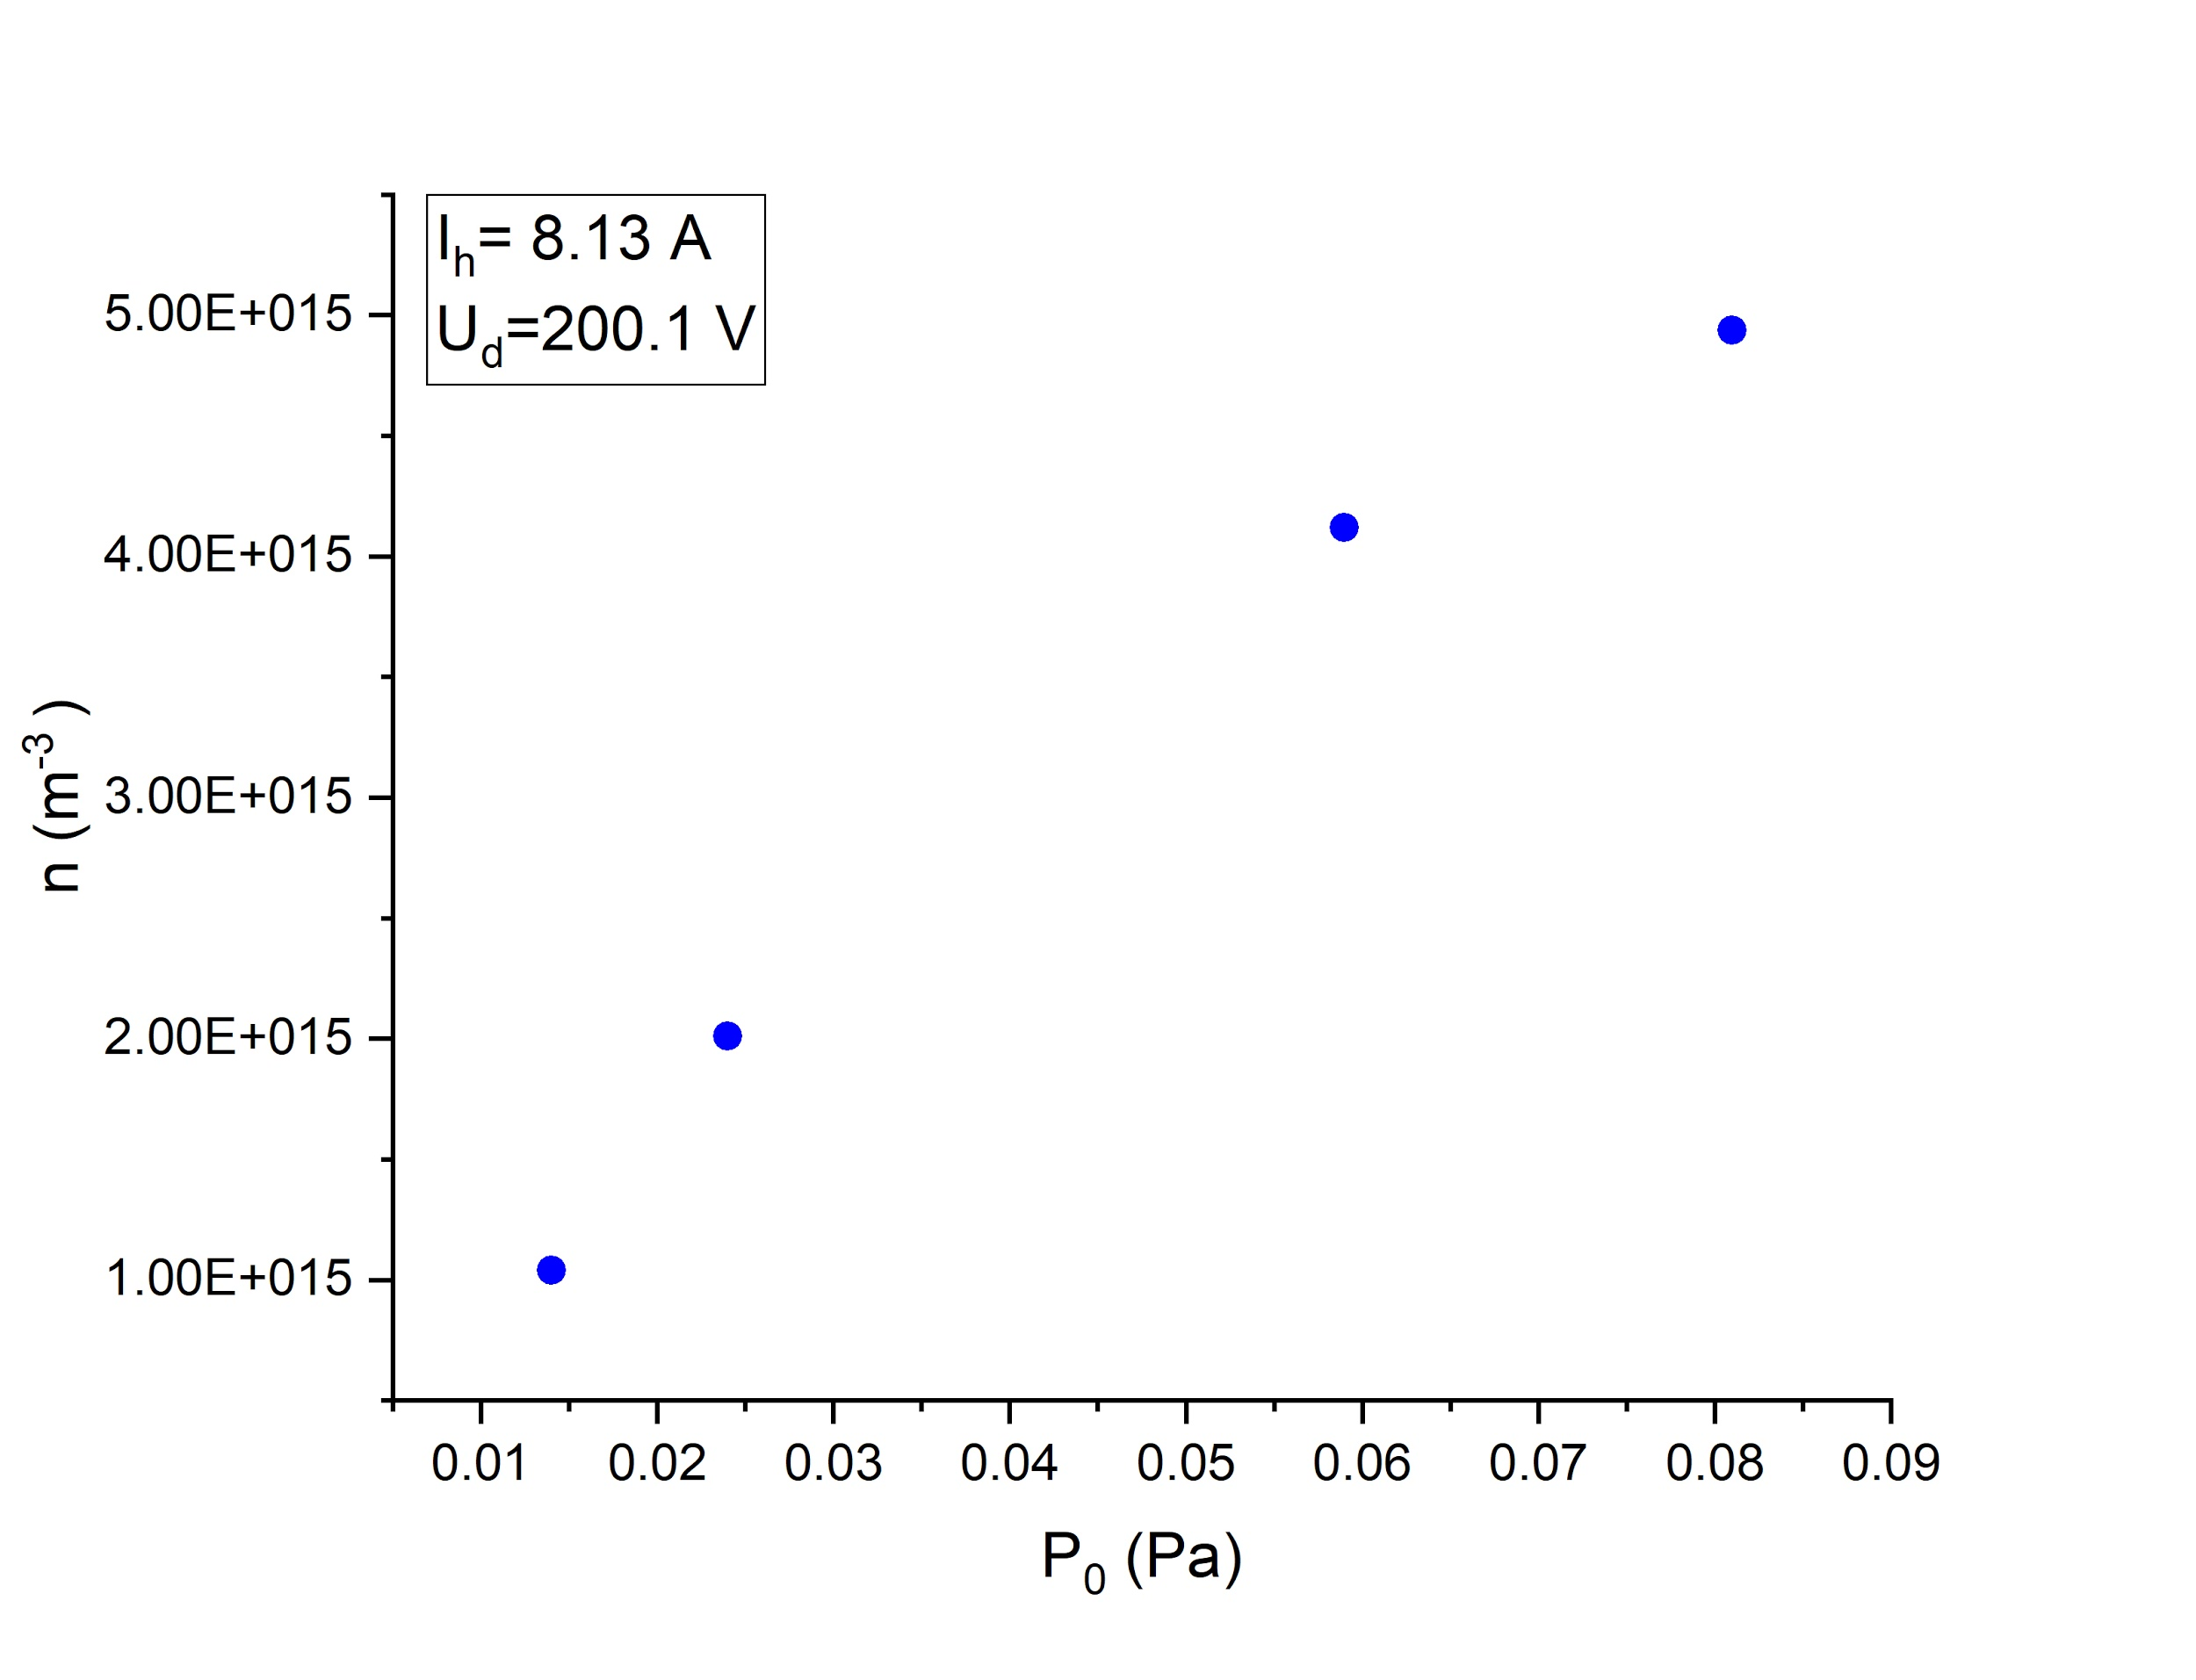

|  |  |  |  |  |
| --- | --- | --- | --- | --- |
| **P (Pa)** | **fpe  (GHz)** | **n (m-3 )** | **n0 (m-3 )** |  |
| 0.081 | 631.708 | 4.93E15 | 1.96E19 | 2.53E-4 |
| 0.059 | 576.320 | 4.11E15 | 1.42E19 | 2.89E-4 |
| 0.024 | 402.560 | 2.01E15 | 5.79E18 | 3.47E-4 |
| 0.014 | 289.520 | 1.04E15 | 3.38E18 | 3.08E-4 |

# From these measurements, it is observed that the number density of charged particles increases with the neutral gas pressure (which is proportional to the number density of neutral particles). Since for these measurements the number of emitted electrons and their energy is constant, the change in the ionization must be due to an increase in the ionization probability with the neutral density.

For the next measurement, the heating current is varied, thus changing the number of thermionic electrons emitted from the filament.

|  |  |  |
| --- | --- | --- |
| Ih (A) | fpe (GHz) | n (m-3 ) |
| 7.4 | 186.974 | 4.33E14 |
| 8 | 288.860 | 1.03E15 |
| 9 | 475.398 | 2.80E15 |

An increase in the density of charged particles is observed as the heating current increases. This is explained by the probability of ionization collisions being proportional to the number of electrons being emitted from the filament.

And for the third and last set of measurements, the bias potential of the filament will be changed while the other control parameters remain constant.

|  |  |  |
| --- | --- | --- |
| Ud (V) | fpe(GHz) | n (m-3 ) |
| 200.1 | 631.708 | 4.95E15 |
| 99.7 | 314.846 | 1.23E15 |
| 50.7 | 186.684 | 4.32E14 |

# 

# The increase of the charged particle density in this case with $Ud_{}$ is explained by the dependency of the ionization cross section with the kinetic energy of the electrons, as we have seen previously.

**IV.III Dispersion Relation and Damping of ion acoustic waves (IAW).**

For this third part of the experiment, the focus is observing the ion acoustic standing waves excited in the target chamber by applying an alternating sinusoidal voltage signal to the metal mesh separating both halves of the chamber. The waves have been observed by using a Langmuir probe that can move along the axis of the cylinder to measure the amplitude of the waves at different distances from the origin at the steel mesh. The Langmuir probe is applied a bias voltage of 50V in order to operate it in the electron saturation current regime to better observe the amplitude. The measurements are taken for 3 different pressures of the neutral gas and 4 frequencies of the signal for each value of the pressure.

The modus operandi consists of moving the Langmuir probe away from the wave origin and looking at the values of the amplitude to observe where the maxima are. From the distance between maxima, the half of the wavelength can be obtained. By measuring the amplitude at each maximum, the dampening of the wave with distance from the source can be observed.

By using the dispersion relation, the velocity of sound in the plasma is calculated from the wavelength and the frequency. And from this value, the electron temperature can also be obtained. Ref eq

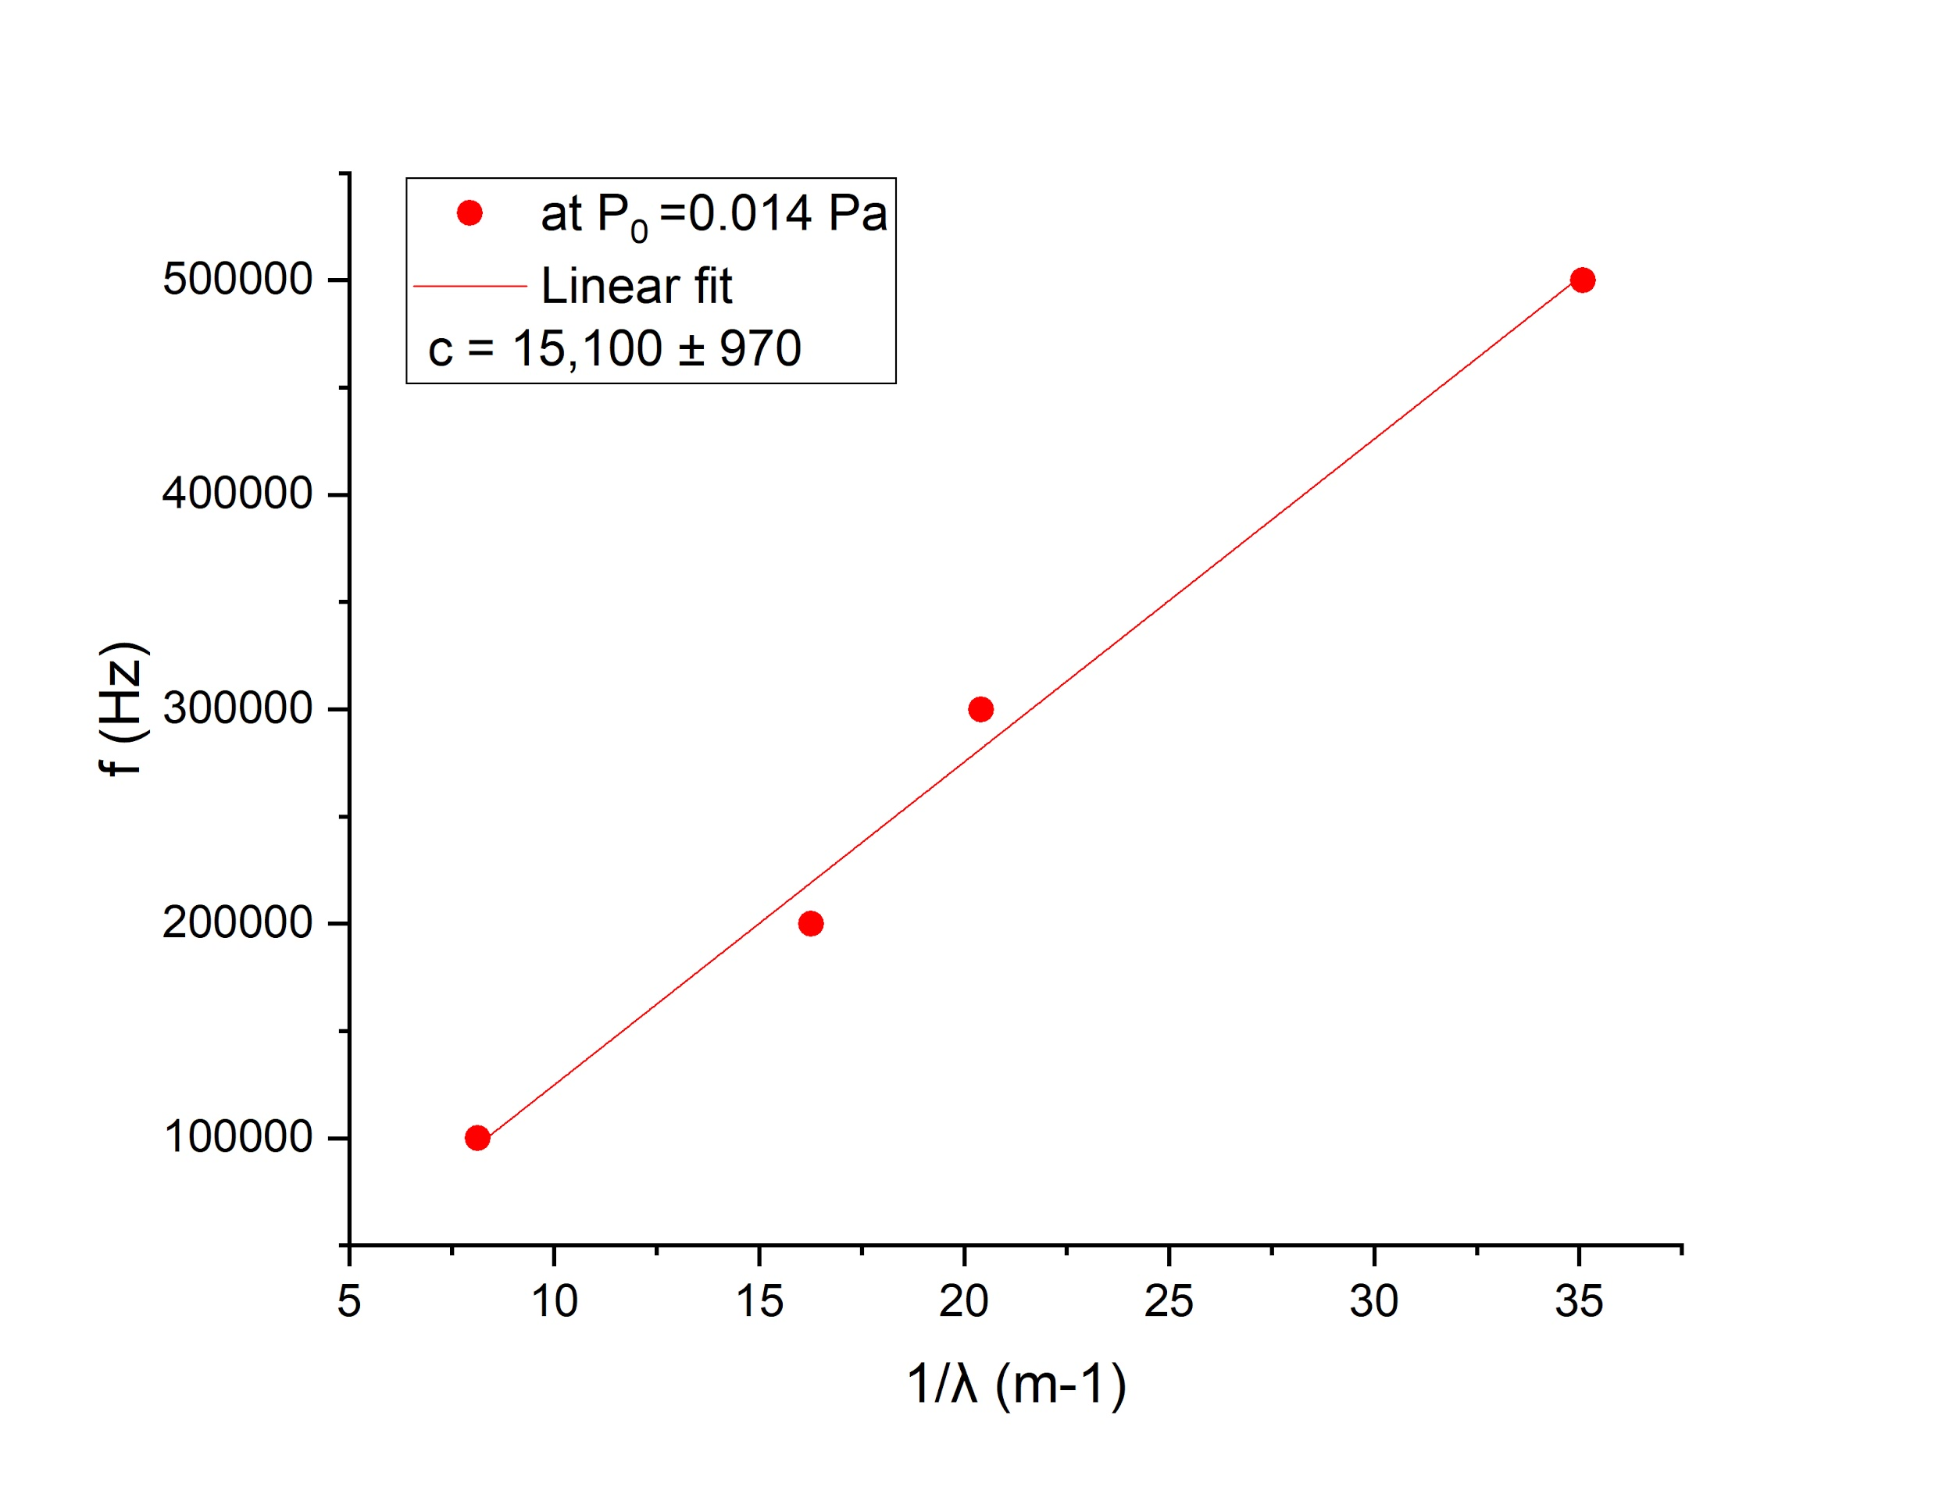

# This graph shows the relation of the frequency with the inverse of the wavelength. The slope of the linear fit of the data provides the propagation velocity (cs) of the waves. Two other linear fits are made for the two other higher values of the neutral gas pressure and the following results are achieved:

|  |  |  |  |
| --- | --- | --- | --- |
| P0  (Pa) | Cs (m/s) | Te (eV) for He | Te (eV) for Ar |
| 0.014 | 15100 ± 970 | 9.5 ± 1.2 | 94.4 ±6.1 |
| 0.036 | 11580 ± 180 | 5.56 ±0.17 | 55.51 ±0.89 |
| 0.065 | 11670 ± 320 | 5.67 ±0.29 | 56.37 ± 1.5 |

The experiment was performed with a mixture of helium and argon introduced in the chamber. Since the proportion of these two gases in the mixture is unknown to us, for the calculation of the electron temperature, we have assumed the extreme cases in which the gas were pure helium or pure argon, in order to delimit the real value (which must be between the two).

A decrease in the electron temperature is observed as the neutral pressure increases, and the same occurs for the sound velocity. This can be explained as an energy exchange between the electrons and the neutral background, at a negligible temperature. This exchange could be produced by elastic collisions between the electrons and the neutral particles. The magnitude of this energy exchange is expected to be higher with higher neutral particle concentrations because the rate of these collisions would increase too.

To measure the damping length of the acoustic waves in the plasma, we analyse the amplitude at the different maxima and fit the data to a negative exponential curve. From the decay rate of the curve the damping length is obtained:

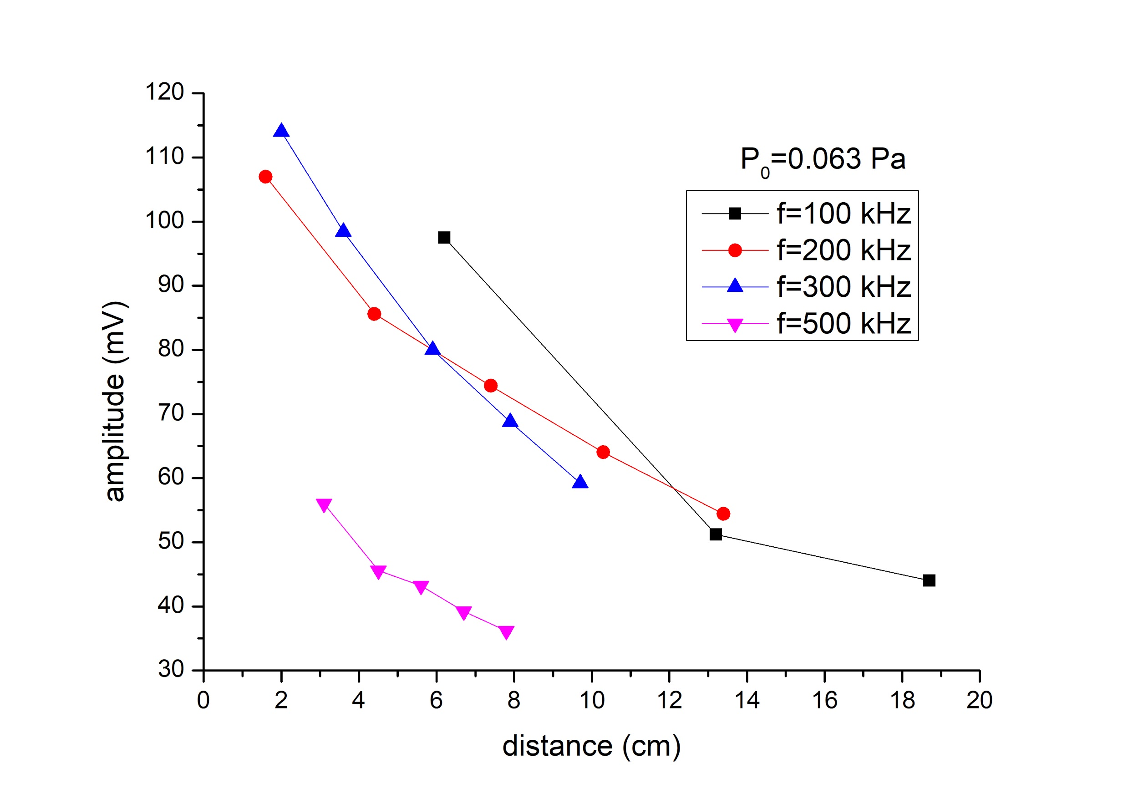

This graphic represents the decay of the amplitude with the distance from the grid at 0.063 Pa. For each of the three pressures at which the measurements is taken, we have four curves, corresponding to these four frequencies. In order to analyse the relation of the damping length with the pressure, the damping length for the same frequency is analyse for the three pressures. We have found that that the curve that shows the best approximation by a decreasing exponential for all three pressures is the curve given by the 200 kHz frequency.

The ion plasma frequency is 50 to 160 (depending on the gas mixture) times higher than the wave frequency and also, for a weakly ionized plasma, the temperature of the ions is assumed to be much lower than that of the electrons. So none of the two circumstances necessary for Landau damping to predominate are present in the experiment. Therefore we can assume the damping mechanism due to collisions with the neutral background to determine the damping length observed in the experiment.

From the equations (11) and (12) from the script, corresponding with damping due to collisions with the neutral background, we can derive the following relation for the neutral particle density:

$n_{0 }= 2 c_{s }/ (v_{th }· σ_{0 }· L_{d })$

# 

With $v_{th }=(8 k_{B }T/ m_{e} π) ^{1/2 }$

For the electron-neutral elastic scattering cross section we have taken the values given in the script for each gas for the appropriate energy range ( $5·10^{-20 }m^{2 }$ for the He and $1·10^{-19 }m^{2 }$ for Ar)

|  |  |  |  |  |
| --- | --- | --- | --- | --- |
| **P 0 (Pa)** | **Ld (cm)** | **n0 (damping) for He** | **n0 (damping) for Ar** | **n0 (ideal gas at 300K)** |
| **0.014** | **5.8 ± 3.0** | 5,05E18 | 8.01E17 | 3,38E18 |
| **0.036** | **11.8 ± 3.5** | 2,49E18 | 3.94E17 | 8,69E18 |
| **0.063** | **9.0 ± 2.5** | 3,26E18 | 5.16E17 | 1,52E19 |

# 

The neutral particle density calculated from the damping length is within an order of magnitude of the expected by using the ideal gas equation. From this it can be confirmed that the damping mechanism is the collision of the electrons with the neutral particles.

As it is established that the damping mechanism is due to the collisions with the neutral background, it would be expected for the damping length to decrease with higher neutral pressures. However, our error in the damping length calculation from the exponential fitting of the amplitude is too great to confirm experimentally this behaviour.

**IV.IV Transition to the non-linear regime**

For this last part of the experiment, we observed the response of the plasma to high amplitude and step-like functions in a qualitative way. The response of the plasma is observed in the oscilloscope connected to the Langmuir Probe inside the plasma. There, the shape of the excitation wave showed non-linear behaviour like, for example, truncated sinusoidal functions. This is because for high amplitudes the perturbation in the density caused by the excitation wave exceeds 10% of the density of the plasma and this causes the propagation of the wave at velocities higher than the speed of sound in the medium, which creates a shock wave.

# 

# 

# References

[1] Piel, Alexander. Plasma Physics: An Introduction to Laboratory, Space and Fusion Plasmas (2010, Springer). Chapter 4: Stochastic Processes in a Plasma.

Lastname, C. (2008). Title of the source without caps except Proper Nouns or: First word after colon. *The Journal or Publication Italicized and Capped*, Vol#(Issue#), Page numbers.

Lastname, O. (2010). Online journal using DOI or digital object identifier. *Main Online Journal Name*, Vol#(Issue#), 159-192. doi: 10.1000/182

Lastname, W. (2009). If there is no DOI use the URL of the main website referenced. *Article Without DOI Reference*, Vol#(Issue#), 166-212. Retrieved from<http://www.example.com>